PHYSICS

UNITS 1 & 2

2018


Name:_______________________________________________________

Teacher: ___________________________________________________

TIME ALLOWED FOR THIS PAPER

Reading time before commencing work: Ten minutes
Working time for the paper: Three hours

MATERIALS REQUIRED/RECOMMENDED FOR THIS PAPER

To be provided by the supervisor:
- This Question/Answer Booklet; Formula and Constants sheet

To be provided by the candidate:
- Standard items: pens, pencils, eraser or correction fluid, ruler, highlighter.

- Special items: Calculators satisfying the conditions set by the SCSA for this subject.

IMPORTANT NOTE TO CANDIDATES
No other items may be taken into the examination room. It is your responsibility to ensure that you do not have any unauthorised notes or other items of a non-personal nature in the examination room. If you have any unauthorised material with you, hand it to the supervisor before reading any further.

Structure of this paper

Section | Number of questions available | Number of questions to be answered | Suggested working time  (minutes) | Marks available | Percentage of exam
Section One:  Short answer | 12 | 12 | 50 | 54 | 30
Section Two:  Extended answer | 7 | 7 | 90 | 90 | 50
Section Three:  Comprehension  and data analysis | 2 | 2 | 40 | 36 | 20
 |  |  | Total | 180 | 100

Instructions to candidates

- Write your answers in this Question/Answer Booklet.

- When calculating numerical answers, show your working or reasoning clearly. Give final answers to three significant figures and include appropriate units where applicable.

When estimating numerical answers, show your working or reasoning clearly. Give final answers to a maximum of two significant figures and include appropriate units where applicable.

- You must be careful to confine your responses to the specific questions asked and follow any instructions that are specific to a particular question.

- Spare pages are included at the end of this booklet. They can be used for planning your responses and/or as additional space if required to continue an answer.
  - Planning: If you use the spare pages for planning, indicate this clearly.
  - Continuing an answer: If you need to use the space to continue an answer, indicate in the original answer space where the answer is continued, i.e. give the page number. Refer to the question(s) where you are continuing your work.

Section One: Short response 30% (54 Marks)

This section has twelve (12) questions. Answer all questions. Write your answers in the space
provided. Suggested working time for this section is 50 minutes.

Question 1 (4 marks)

a) Determine the wavelength of a sound that is produced at 5.00 kHz when the speed in air is
340 m s⁻¹.

Answer:________________________

b) Sound waves can also transmit through a solid medium. If the 5.0 kHz sound wave reached the wooden barrier, show how the sound path and wavefronts would change as it moved into the faster wood medium.

Question 2 (4 marks)
100 g of ice is taken from a freezer where it is kept at -6.00°C. It is heated until it becomes steam at 1.10 x 10² °C. Calculate how much energy it has absorbed.

Answer:_______________________

Question 3 (4 marks)
A 0.10 kg hockey puck is at rest. A force of 20.0 N acts on it for 0.20 s, which sets it in motion. Over the next 2.00 s it encounters an average of 0.40 N frictional force. Lastly, a force of 24.0 N acts for 0.05 s in the direction of motion. Calculate the puck’s final speed.

Answer:_______________________

Question 4 (4 marks)
Devil’s Lair is a small cave near Margaret River, South of Perth. Its name comes from the Tasmanian Devil remains found amongst other bones in the cave. Artefacts from the cave show that aboriginal people have been living in the area for up to 5.0 x 10⁴ years. A sample of petrified wood from a spear shaft has a measured carbon-14 decay rate of 6.00 counts per minute per gram. The decay rate of carbon-14 in fresh wood today is 13.6 counts per minute per gram. Calculate the age of the spear shaft, in years. The half-life of C-14 is 5730 years.

Answer:_______________________

Question 5 (4 marks)
Horsepower (hp) is an old unit to measure Power, the rate at which work is done. The diagram below shows that 1.00 hp is needed to lift a 75.0 kg mass by 1.00 m in 1.00 s.
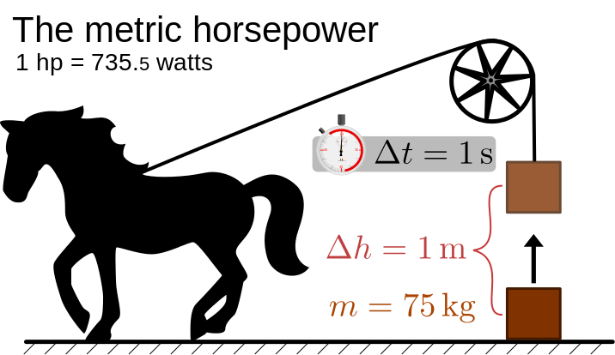

- Show by calculation that 1.00 hp = 735 W. (2 marks)

Answer:_______________________

- If a 12.5 hp air conditioner is working for 2 minutes 15 seconds, calculate how much work has been done. (2 marks)

Answer:_______________________

Question 6 (4 marks)
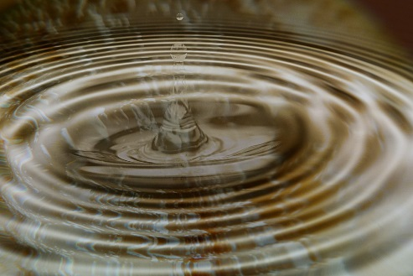
A stone is dropped into a still pool of water. It generates 20 waves that spread out a distance of 10.0 m from where it entered the water. The outer wave covers the 10.0 m in a time of 5.00 s and the average height of the waves is 10.0 mm (crest to trough).

- Determine the wavelength and velocity of the waves.
(2 marks)

Wavelength:_____________________

Velocity: _______________________

- Calculate the period of the water waves. (2 marks)

Answer:_______________________

Question 7 (6 marks)
Sophie is drying her hair with a hair dryer. During this period the hair dryer drew a current of 5.50 A from a 240 V supply.

- Estimate how much charge passed through the hair dryer in the time it took to dry her hair. (3 marks)

Answer:_______________________

- Calculate the resistance of the heating coil of the hair dryer. (1 mark)

Answer:_______________________

- Calculate the power rating of the hair dryer. (2 marks)

Answer:_______________________

Question 8 (5 marks)

A keen bushwalker went for an extended hike as shown by the following graph.
F
E
G
D
C
B
A

Use the graph to determine the following information:

- How far did the hiker walk? (1 mark)

Answer:________________________

- Calculate the velocity (km h⁻¹) in the segment CD. (2 marks)

Answer:________________________

- Sketch a graph of velocity versus time for the bushwalker’s hike. (2 marks)

Question 9 (4 marks)

The figure below shows a skier being pulled by rope up a hill of incline 12.0° at a
constant speed. The total mass of the skier is 85.0 kg. Two of the forces acting on
the skier are already shown.

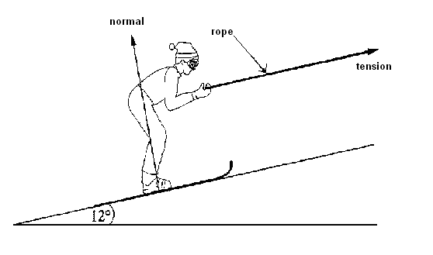

Mark with arrows and label on the diagram above a further two (2) forces that are acting on the skier. (1 mark)

b) Calculate the minimum tension in the rope pulling on the skier. (3 marks)

Answer:_______________________

Question 10 (7 marks)
On the way to school, a student decides not to use the pedestrian bridge to cross a busy road, and decides instead to run across the road. He sees a car 100 m away travelling towards him, and is conﬁdent that he can cross in time.

- The car is travelling at 105 km h⁻¹ and the student can run at 10.0 km h⁻¹, calculate their respective speeds in m s⁻¹. (2 marks)

Car___________________ Student ___________________

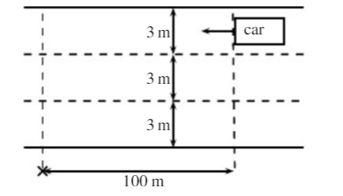
- If the road has 3 lanes, and each lane is 3 m wide, how long will it take for the student to cross all three lanes, from kerb to kerb? (2 marks)

Answer:_______________________ (2 marks)

- If the car is travelling in the furthermost lane from the student, will he be able to cross all three (3) lanes of the road safely? Justify your answer with a calculation. (3 marks)

Answer: ______________________

Calculation:

Question 11 (5 marks)
A 240 V electric kettle is used to heat 2.80 x 10² mL of water initially at 22.0 ⁰C. The heating element draws a current of 1.80 A, and is left on for 3 minutes. Determine the final temperature of the water, assuming 85% efficiency.

Answer:_______________________

Question 12 (3 marks)
In a game of 10-pin bowling, a person bowls a 10.5 kg bowling ball so that it hits the last remaining 1.0 kg bowling pin at 2.4 m s⁻¹ and continues after the collision at 1.94 m s⁻¹. Calculate the speed of the pin immediately after the collision.

Answer:_______________________

End of Section One

This page has been left blank intentionally

Section Two: Problem-solving 50% (90 Marks)

This section has seven (7) questions. You must answer all questions. Write your answers in the
space provided. Suggested working time for this section is 90 minutes.

Question 13 (16 marks)


A solar camp shower is a device to heat water for a shower when other sources of energy are unavailable. The bag is simply hung in a sunny spot for a period of time. A typical camp shower would hold 20.0 litres of water.

- Explain why the bag is black in colour. (1 mark) (1 mark)

__________________________________________________________________________________________________________________________________________________________________________________________________________________________________________________________________________________________

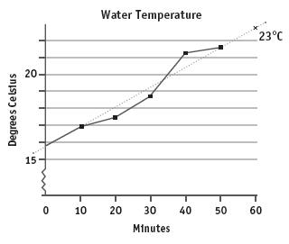
- Examine the graph to the right, which shows how on a certain day, the temperature of water changes with time.

- State and briefly explain one reason why the temperature of the water is not increasing at a constant rate.
______________________________________________________________________________________________________________________________________________________________________________________________________________________________________________________________________________ (2 marks)

- Use the graph’s line of best fit to calculate the average rate at which the water is heated. Express your answer in ºC min⁻¹.
(2 marks)

Answer:_______________________
- How long would it take to heat the water to 30.0 ºC? (2 marks)

Answer:_______________________

- Calculate the amount of energy 20.0 litres of water needs to absorb to be heated from
15.8 ºC to 30.0 ºC.
(1 mark)

Answer:_______________________

- The average amount of solar radiation received at the Earth's surface is
1.37 x 10³ W m⁻². The camp shower bag has an absorbing area of 0.40 m².

- Calculate the rate at which solar energy falls on the bag. (2 marks)

Answer:_______________________

- If 100% of this energy was to go into heating water, how long would it take to heat 20.0 litres of water from 15.8 ºC to 30.0 ºC (3 marks)

Answer:_______________________

- Calculate the efficiency of the camp shower at converting the solar energy it receives into thermal energy in the water. (3 marks)

Answer:_______________________
Question 14 (13 marks)

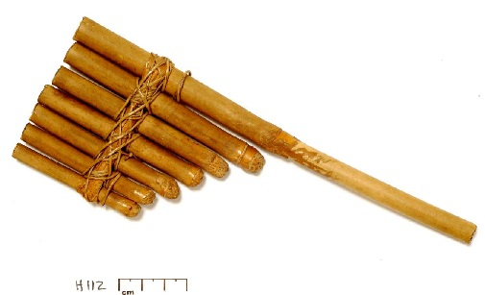
Panpipes, or pan flutes, can be traced back to Greek, Mayan, Native American, and many other ancient cultures. Although the sizes and styles differ across cultures, the basic design is a series of closed-end tubes of varying length, fixed together.
The sound is produced by blowing into the pipes and setting the column of air inside into motion. Once the wave pattern is stabilised it is known as a standing wave.

- Will the closed end of the tube always serve as a displacement node or an antinode? Briefly explain your answer in terms of interference of waves.
(2 marks)
________________________________________________________________________________________________________________________________________________________________________________________________________________________________________________________________________________________________________________________________________________________________________________________________________________________________________________

- Determine the relationship between the wavelength of the fundamental frequency and the length of the tube. (1 mark)

Answer:_______________________

- If a pipe of length 30.4 cm was made to resonate at its fundamental frequency, calculate the frequency of sound produced. (2 marks)

Answer:_______________________
- The tube is now vibrating with a standing wave pattern of three antinodes and three nodes.
Draw a particle displacement diagram below and state which overtone this represents. your answer. (2 marks)

Overtone: ____________

- Explain how a standing wave forms and the conditions that are necessary.
(2 marks)

____________________________________________________________________________________________________________________________________________________________________________________________________________________________________________________________________________________________________________________________________________________________________________________________________________________________________________________________________________________

- An internet guide to making your own panpipe suggests that each pipe is 9/8 the length
of the previous pipe. One of the pipes resonates at its 3rd harmonic, producing an A note of 440 Hz.

Calculate the frequency of the fundamental note produced by the pipe 3 “steps” longer than this. (4 marks)
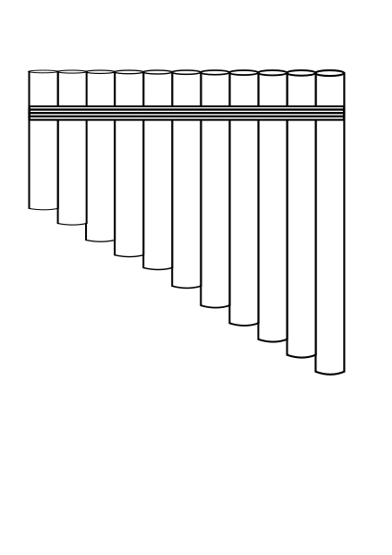

Answer:_______________________
Question 15 (14 marks)

Alexia set up the electrical circuit shown below for her Physics investigation. The circuit is powered
by a 24 V DC power source and has a single switch S.

A
24 V
S
2 Ω
3 Ω
6 Ω
3 Ω
P
Q
V
  - ON THE CIRCUIT DIAGRAM, draw in the direction of conventional current flow.
(1 mark)
  - Calculate the total resistance of the circuit. (4 marks)

Answer: _________________________________
  - Calculate the current recorded by the ammeter when the switch is closed. (2 marks)

Answer: _________________________________

  - Assuming the current measured by the ammeter is 5.65 A, calculate the electric charge delivered by the DC power source in 2 hours and 35 minutes. (3 marks)

Answer: _________________________________

  - If the voltage drop between P and Q is 12.7 V,

    - Calculate the voltage drop recorded by the voltmeter. (2 marks)

Answer: _________________________________
    - Calculate the power consumed by the 6.00 Ω resistor. (2 marks)

Answer: _________________________________
Question 16 (12 marks)
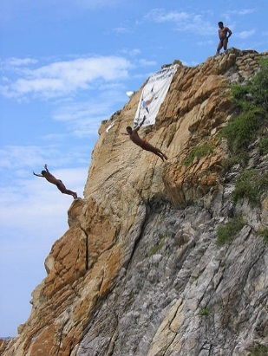
The La Quebrada Cliff Divers® are a group of professional high divers based in Acapulco, Mexico. They regularly dive head first from a height of 36.0 m into a narrow inlet of ocean water. The water depth varies from 1.80 m to 4.90 m as the ocean waves surge in and out of the inlet. The average depth is 3.60 m.
- A diver jumped verically upwards from the cliff with an initial vertical velocity of 3.5 m s⁻¹. Calculate the kinetic energy of a 60.0 kg diver at the instant he reached the water.
(4 marks)

(4 marks)

Answer:_______________________

- If he came to stop at a depth of 3.00 m, what average vertical force must the water exert on him? (2 marks)

Answer:_______________________

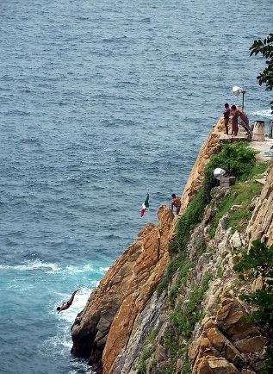
- The divers time their dive by observing the waves at the entrance of the inlet, to their right. The aim is to land as the wave passes under them, hence the water is at a maximum depth. Calculate how far away from the landing zone a wave peak travelling at 12 m s⁻¹ would need to be for the diver in part a) to hit the water when at its maximum depth.
(4 marks)
(4 marks)

Answer:_______________________
- The rocks at the base of the cliff protrude horizontally 4m into the water from where the divers jump. Explain, in terms of forces, why a diver would be killed if they hit these rocks.
(2 marks)

______________________________________________________________________________________________________________________________________________________________________________________________________________________________________________________________________________________________________________________________________________________________________________________________________

Question 17 (11 marks)

Nuclear Fusion is the process that powers our Sun and stars as smaller nuclei fuse together to form larger ones, and matter is converted into energy. When Hydrogen is heated to very high temperatures, its electrons are separated from the nuclei and the gas changes to a plasma. These high temperatures are also needed to overcome strong repulsive forces.

- Describe the origin of the “strong repulsive forces” mentioned above. (2 marks)

________________________________________________________________________________________________________________________________________________________________________________________________________________________

- Write a nuclear equation for the fusion of a Deuterium (${}_{1}^{2}H)$ nucleus and a Tritium (${}_{1}^{3}H)$ nucleus to form a ${}_{2}^{4}{He}$ nucleus, one other particle, and energy. (2 marks)

_______________________________________________________________________

- Given the data below, determine the amount of energy (in J) released by the reaction in b). (5 marks)
m (${}_{1}^{2}H)$ = 2.01410178 u
m (${}_{1}^{3}H)=$ 3.01604927 u
m $({}_{2}^{4}{He})$ = 4.00260325 u

Answer:_______________________

- Determine how much energy would be released by 1 kg of hydrogen gas. (2 marks)
(Assume equal number of particles of H-2 and H-3 in sample and that all atoms fuse.)

Answer:_______________________

Question 18 (8 marks)

Fuses provide a way of helping to protect people against electrocution. They are generally a short length of wire which is designed to melt when the current in the circuit exceeds a certain amount.

- Describe why the wire will melt when a high current passes through it. (2 marks)

________________________________________________________________________________________________________________________________________________________________________________________________________________________________________________________________________________________________________________________________________________________________________

- State what would have to happen to the resistance of a circuit for the current to increase. Under what conditions would this happen? (2 marks)

________________________________________________________________________________________________________________________________________________________________________________________________________________________________________________________________________________________________________________________________________________________________________

- In a house, a lighting circuit might use a 20.0 A fuse, whilst an oven would use 40.0 A. State which of these circuits requires a fuse with a thicker wire. (1 mark)

Answer ___________________

- State one (1) disadvantage of fuses, compared to a residual current device (RCD).
(1 mark)
________________________________________________________________________________________________________________________________________________________________________________________________________________________________________________________________________________________________

- List two (2) other electrical safety devices or features commonly used in a home. (2 marks)

- _________________________________________________________________
- _________________________________________________________________

Question 19 (16 marks)

When an object such as a metal rod is heated, its length will almost always increase. A measure of the rate at which this increases is called the coefficient of linear expansion$α_{L}$. It is the fractional change in length per degree of temperature change, and can be expressed as:

$α_{L}=\frac{∆L}{L_{o}}. \frac{1}{∆T}$
Where $L_{o}$ is the initial length of the sample material, $∆L$ is the amount by which it has expanded and $∆T$ is the change in temperature.
This equation works well as long as the linear-expansion coefficient does not change much over the change in temperature and the fractional change in length $\frac{∆L}{L_{o}}$ is small.

In an experiment to determine the coefficient of linear expansion of Aluminium, a sample of
known length, $L_{o}=$ 6.00 x 10² mm was placed in a sealed chamber, and heated with steam at
1.00 x 10^{2 o}C, then allowed to cool. The length of the bar was recorded each drop of 2 ºC until the
temperature inside the chamber reached 50.0 ºC.

- Explain, using the kinetic particle model of matter, why substances expand when heated.
(3 marks)
________________________________________________________________________________________________________________________________________________________________________________________________________________________________________________________________________________________________________________________________________________________________________

The results for the experiment are as follows:

ΔTemp (ºC) | $∆L$ (mm) | $$\frac{∆L}{L_{o}}$$
99 | 0.99 | 0.00165
96 | 0.97 | 0.00161
94 | 0.94
92 | 0.92
90 | 0.9 | 0.00151
88 | 0.87 | 0.00145
84 | 0.82 | 0.00136
82 | 0.79
80 | 0.77

- Complete the third column, $\frac{∆L}{L_{o}}$ in the table above. Some values are already done.
(2 marks)

- On the graph paper provided, plot a graph of $\frac{∆L}{L_{o}}$ on the y-axis and ΔT on the x-axis. You may break the x-axis. (A spare grid is supplied at the end of the paper.) (4 marks)

- Draw the line of best fit for your data. (1 mark)

- Using your line of best fit, calculate the coefficient of linear expansion for the sample used. Show all relevant calculations and working. (4 marks)

- The theoretical value of α_{L} for Aluminium is 23.8 x 10⁻⁶ ºC⁻¹. Calculate the percentage error in the experimental value obtained. (If you were unable to calculate a value for part e), use 23.0 x 10⁻⁶ ⁰ C⁻¹). (2 marks)

Answer:_______________________

End of Section 2
Section Three: Comprehension 20% (36 Marks)

This section contains two (2) questions. You must answer both questions. Write your answers in
the spaces provided. Suggested working time for this section is 40 minutes.

Question 20 (18 marks)

The Great Eastern Japan Earthquake and Tsunami
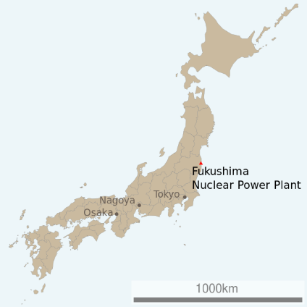
On March 11, 2011 at 2:45 pm a massive earthquake occurred off the North East Coast of Japan. The hypocentre was at an underwater depth of approximately 29.0 km.

Less than an hour after the earthquake, the first of many tsunami waves hit Japan's eastern coastline. It is estimated that the tsunami waves were travelling at about 340 km h⁻¹ with wavelengths averaging 280 km when they encountered the coastline. The tsunami waves reached run-up heights (how far the wave surges above sea level as it hits the land) of up to 39 m at Miyako city and travelled inland as far as 10 km in some places.

The tsunami waves also travelled across the Pacific, reaching Alaska, Hawaii and Chile. In Chile, some 17,000 km distant, the tsunami waves were 2 m high when they reached the shore. The earthquake produced a low-frequency rumble called infrasound, which travelled into space and was detected by the GOCE satellite.

As well as the devastation from the tsunami, several nuclear power stations were damaged, releasing significant amounts of radioactive material into the atmosphere. Some 55 000 households were displaced and evacuation zones of up to 100 km from the reactors were established.

The following table is from reports released by Japan’s Atomic Energy Commission a year after the disaster, estimating the amount of various isotopes released into the atmosphere and the ocean:

Isotope | Estimated amount released (TBq)
iodine-131 | 511,000
caesium-134 | 13,500
caesium-137 | 13,600
Strontium-90 | 8,300

- Iodine-131 is easily absorbed by the thyroid, so persons exposed to releases of I-131 have a higher risk of developing thyroid disease. Children are more vulnerable to
I-131 than adults. I-131 decays by beta minus and gamma emissions with a short half-life at 8.02 days.
- Caesium-137 has a long, 30-year half-life. Internal exposure to Cs-137, through ingestion or inhalation, allows the radioactive material to be distributed in the soft tissues, especially muscle and lung tissue, exposing these tissues to the beta particles and gamma radiation.
- Strontium-90 behaves like calcium (20–30% of ingested Sr-90 is absorbed and deposited in the bone and bone marrow). It undergoes β−decay into Yttrium-90, with a half-life of 28.8 y.

On 22 March, World Nuclear News reported that 6 workers had received over 100 mSv, and one of over 150 mSv. On 24 March, three workers required hospital treatment after radioactive water seeped through their protective clothes. The injuries indicated exposure of 2000 to 6000 mSv around their ankles, with whole body doses of about 170 mSv. They were not wearing protective boots, as their employing firm's safety manuals "did not assume a scenario in which its employees would carry out work standing in water at a nuclear power plant".

Questions:

- As the Tsunami waves travel in deep water, they can be approximated as a sine wave. On the diagram below, clearly indicate the amplitude and wavelength of the wave. (2 marks)
displacement
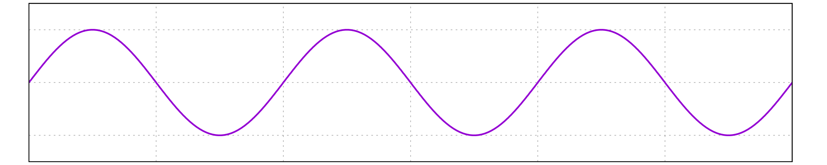
Distance from source

- Calculate the time between two successive waves hitting the Japanese coastline. (1 mark)

Answer:_______________________

- As a result of their long wavelengths, tsunamis act as shallow-water waves. A wave becomes a shallow-water wave when the wavelength is very large compared to the water depth. Shallow-water waves move at a speed, c, that is dependent upon the water depth and is given by the formula:
$$c= \sqrt{gH}$$

where g is the acceleration due to gravity and H is the depth of water, in metres.

- Refer to the equation above to state what would happen to the speed of the tsunami wave as it approached the shore.

(1 mark)
________________________________________________________________________________________________________________________________________________

- Calculate how long after the earthquake the tsunami wave would reach the shore of Chile if the average ocean depth is 3.00 km. (3 marks)

Answer:_______________________
- Explain why the wave height would only be around 2.00 m when it reached Chile.
(2 marks)
________________________________________________________________________________________________________________________________________________________________________________________________________________________________________________________________________________________________________________________________________________________________________

- The earthquake produced a low frequency rumble, called infrasound. By what factor would the intensity of the infrasound be at half the distance to the GOCE satellite? Justify your answer. (2 marks)

Answer:_______________________

- Which of the isotopes mentioned would cause the most serious health risks in the first weeks after the incident? Explain your answer. (2 marks)
________________________________________________________________________________________________________________________________________________________________________________________________________________________________________________________________________________________________________________________________________________________________________

- Calculate the percentage of I-131 to the total fallout experienced. (1 mark)

- Calculate the amount (in TBq) of Iodine-131 that remained 30.0 days after the accident.
(2 marks)

Answer:_______________________

- Calculate how much energy would need to be absorbed by a 75.0 kg person for them to receive a whole body dose of 170 mSv. (2 marks)

Answer:_______________________

Question 21 (18 marks)
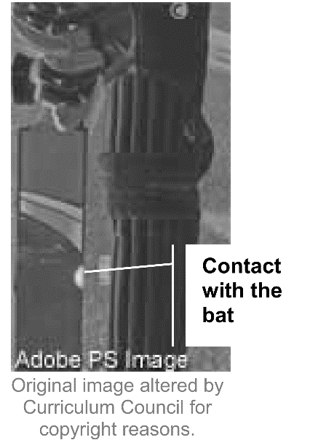

In cricket, a batsman is judged ‘out’ if the ball is caught after hitting the bat.
The batsman is ‘not out’ if the ball is caught after hitting the batsman’s leg.
A cricket umpire must sometimes decide whether the ball hit the bat, the
batsman’s leg, or if both have been hit, which happened first. This can be
tricky because the bat and the leg may be very close together, and the
contact occurs over a very short time.

A technology called Hot Spot can be used to resolve this issue. Hot Spot is
an infra-red imaging system, and is used to determine where, or what, the
ball actually hit. There are two Hot Spot infra-red cameras, one at each end
of the cricket ground. These measure and record the temperature of the bat
and the batsman, before and after the ball makes contact. The infra-red
images are then processed by a computer to show temperature differences
between the ‘before’ and ‘after’ images.

The point is to show accurately whether the ball has hit the bat, the batsman’s glove, the
batsman’s leg, or none of these. The black-and-white images produced by Hot Spot can potentially
allow an umpire to precisely localise the ball’s point of impact, and so reduce the risk of making an
incorrect decision.

a) Using the image above as a reference, which would have the higher temperature? (1 mark)
Circle the correct answer:

a light part a dark part not enough information

b) Explain how the infra-red cameras are able to ‘sense’ where the contact or collision point has
occurred. (1 mark)
______________________________________________________________________________________________________________________________________________________

c) The increase in heat energy of the contact point only lasts for a short time. Explain one form of
heat transfer that is likely to occur in this situation. (2 marks)

_______________________________________________________________________________________________________________________________________________________________________________________________________________________________________________________________________________________________________________________________________________________________________________________

d) A 161 g cricket ball moving at 25.0 m s⁻¹ hits the edge of a stationary bat transferring
18.1 J of energy to the bat. Contact with the bat lasts 4.50 ms. (milliseconds)
(i) Calculate the speed of the ball after the collision. (4 marks)

Answer:_______________________

(ii) The cricket ball bounced off at a right angle to the direction it was originally moving. Determine the magnitude of the change in velocity of the cricket ball. Include a vector diagram. (4 marks)

Answer:_______________________

(iii) Determine the magnitude of the force applied to the bat. (2 marks)

Answer:_______________________

e) At the moment the photograph is taken, about 4.00 g of wood absorb the 18.1 J of energy and increase in temperature. Determine the temperature increase of this portion of the bat, given that the specific heat of the bat is 2.25 × 10³ J kg⁻¹ K⁻¹. (3 marks)

Answer:_______________________

(e) After the ball is struck, it rolls along the ground and comes to a stop. Explain, using physics
concepts. (2 marks)

_______________________________________________________________________________________________________________________________________________________________________________________________________________________________________________________________________________________________________________________________________________________________________________________

End of Questions

Additional working space

Spare grid for graph

End of examination
Acknowledgements

Question 5
Horsepower Diagram
Adapted from – http://commons.wikimedia.org/w/index.php?curid=35217113

Question 6
Ripples in Pond
CC0 Public Domain
Telstra vehicle Specs
Adapted from – https://www.flikr.com/photos/jurvetson/8273926700
https://en.wikipedia.org/wiki/Tesla Model S

Question 9
Indoor Skydiving
http://upload.wikimedia.org/wikipedia/commons

Question 14
Pan Pipes picture
https://commons.wikimedia.org
Line Drawing
https://en.wikipedia.ord

Question 16
Cliff Divers
By User:( WT-shared) Jake73 at wts wikivoyage ,CC By-SA 2.0
https://commons.wikimedia.org

Question 17
Nuclear Fusion
With permission from the World Nuclear Association- http:www.world.nuclear.org/information-library/current-and-future-generation/nuclear-fusion
Thermal expansion coeffient data and diagram.-With permission from Hose Nanjaro Torres. http://www.academia.edu/6905702/implementaion and Analysis of Linear Thermal Expansion

Question 20
Sine Wave
https://commons.wikimedia .org/wiki/File:Wave sine.svg

Question 21
Fukushima.Data on radiation exposure. https:wikipedia.org

